Name: Shriya Ramya Mohan Roll no: 241901106
Question 5:
An employee denies using a specified website during an investigation period. Examine the browser artifacts and prepare chronological order.
Output Screenshots:
1. ChromeHistoryView
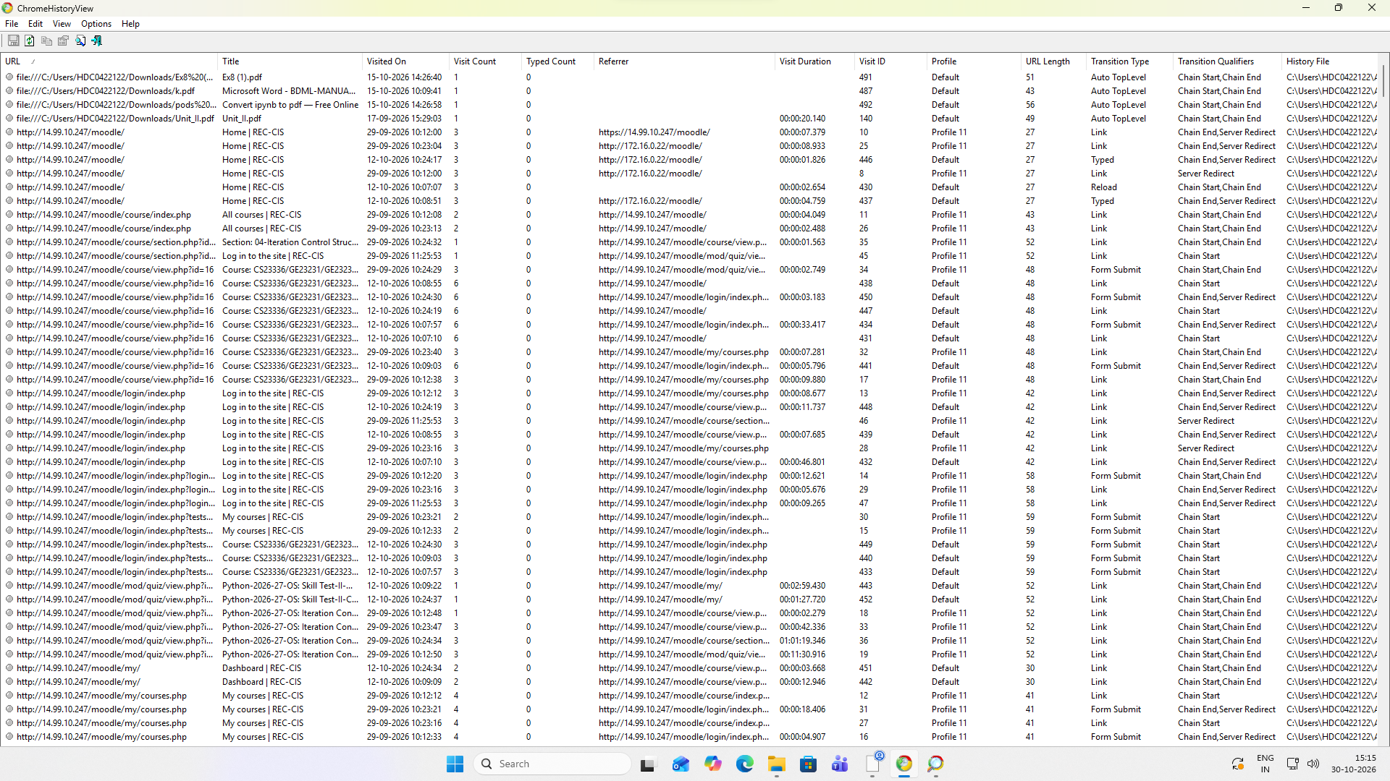
2. ChromeCacheView
